**How to merge multiple PDF pages into a single page using C#**

The Syncfusion Essential® PDF is a feature-rich and high performance [**.NET PDF library**](https://www.syncfusion.com/document-processing/pdf-framework/net) used to create, read, and edit PDF documents programmatically without Adobe dependencies. Using this library, you can combine multiple PDF pages into a single page using C#.

**Steps to combine multiple PDF pages into a single page programmatically:**

1. Create a new console application project.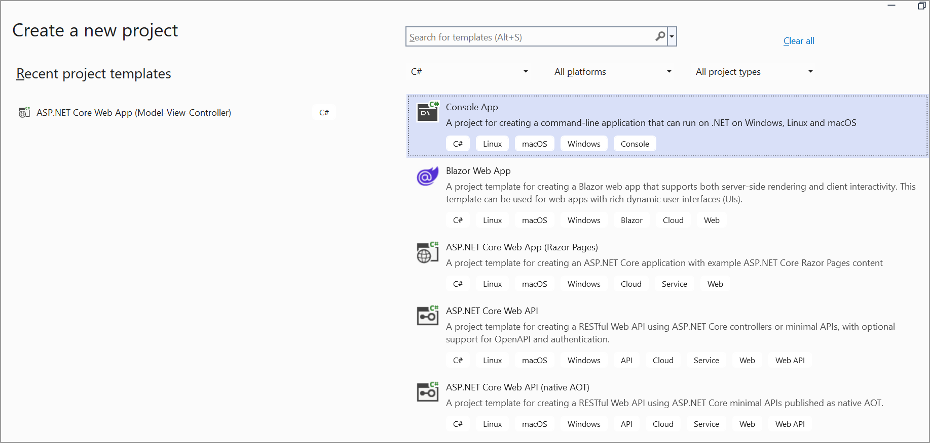
2. Install the **[Syncfusion.Pdf.Net.Core](https://www.nuget.org/packages/Syncfusion.Pdf.Net.Core" \t "_blank)** NuGet package as a reference to your console application from [**Nuget.org**](https://www.nuget.org/).

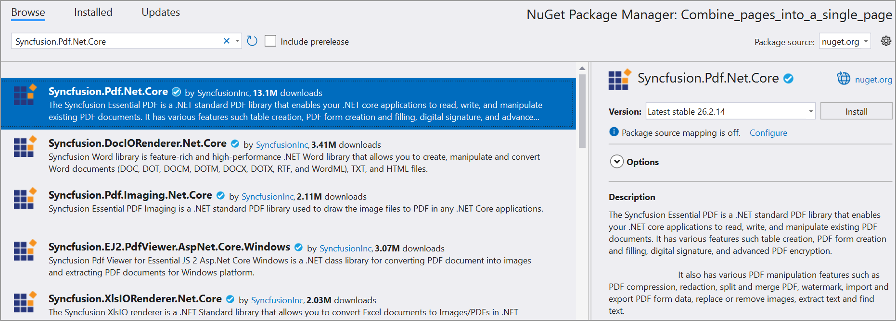

1. Include the following namespaces in the Program.cs file.

**C#**

using **Syncfusion**.Pdf.Graphics;

using **Syncfusion**.Pdf.Parsing;

using **Syncfusion**.Pdf;

using **Syncfusion**.Drawing;

1. Use the following code sample in Program.cs to combine multiple PDF pages into a single page.

**C#**

// Get all PDF files from the specified directory

string[] documents = **Directory**.**GetFiles**(@"../../../", "\*.pdf");

// Create a new PDF document

**PdfDocument** document = **new** **PdfDocument**();

// Set all margins to zero

document.PageSettings.Margins.All = 0;

// Count the number of PDF documents to be merged

int docuCount = documents.Length;

// Set the page size to A4

document.PageSettings.Size = **PdfPageSize**.A4;

// Add a new page to the document

**PdfPage** page = document.Pages.**Add**();

// Get the graphics object for the page

**PdfGraphics** graphics = page.Graphics;

// Initialize location variables for drawing

float yLocation = 0;

float xLocation = 0;

// Calculate the height for each page in the merged document

float pageHeight = **PdfPageSize**.A4.Height / docuCount;

// Loop through each document to merge them

**for** (int i = 0; i < docuCount; i++)

{

// Set the x location based on the current index and page height

xLocation = pageHeight \* i;

// Load the current PDF document

**PdfLoadedDocument** pdfLoaded = **new** **PdfLoadedDocument**(**File**.**OpenRead**(documents[i]));

// Get the first page of the loaded PDF

**PdfLoadedPage** loadedPage = pdfLoaded.Pages[0] **as** **PdfLoadedPage**;

// Create a template from the loaded page

**PdfTemplate** template = loadedPage.**CreateTemplate**();

// Save the current graphics state

graphics.**Save**();

// Translate the graphics context to the right position

graphics.**TranslateTransform**(page.**GetClientSize**().Width, 0);

// Rotate the graphics context to align the PDF correctly

graphics.**RotateTransform**(-270);

// Draw the PDF template onto the page at the specified location

graphics.**DrawPdfTemplate**(template, **new** **PointF**(xLocation, yLocation), **new** **SizeF**(pageHeight, page.**GetClientSize**().Width));

// Restore the graphics state to its previous state

graphics.**Restore**();

}

// Create a file stream to save the document

**FileStream** outputFileStream = **new** **FileStream**("Output.pdf", **FileMode**.Create, **FileAccess**.ReadWrite);

// Save the document

document.**Save**(outputFileStream);

// Close the document

document.**Close**();

A complete working sample can be downloaded from [**Multiple\_PDF\_pages\_into\_a\_single\_page.zip**](https://www.syncfusion.com/downloads/support/directtrac/general/ze/Merge_multiple_PDF_pages-1239700882.zip)

By executing the program, you will get the PDF document as follows.

Take a moment to peruse the [**documentation**](https://help.syncfusion.com/document-processing/pdf/pdf-library/net/merge-documents#merging-multiple-documents-from-disk-and-stream) to merge the multiple PDF documents with [**string array**](https://help.syncfusion.com/document-processing/pdf/pdf-library/net/merge-documents#merging-multiple-documents-from-disk-and-stream) and [**importing pages**](https://help.syncfusion.com/document-processing/pdf/pdf-library/net/merge-documents#importing-pages-from-multiple-documents) from multiple documents with Essential PDF. Also, brief details about [**split**](https://help.syncfusion.com/document-processing/pdf/pdf-library/net/working-with-pages#splitting-a-pdf-file-to-individual-pages), [**delete**](https://help.syncfusion.com/document-processing/pdf/pdf-library/net/working-with-pages#removing-pages-from-a-document) and [**rotate PDF pages**](https://help.syncfusion.com/document-processing/pdf/pdf-library/net/working-with-pages#rotating-an-existing-pdf-page) are available with code examples.

Refer [**here**](https://www.syncfusion.com/document-processing/pdf-framework/net)to explore the rich set of Syncfusion Essential® PDF features.